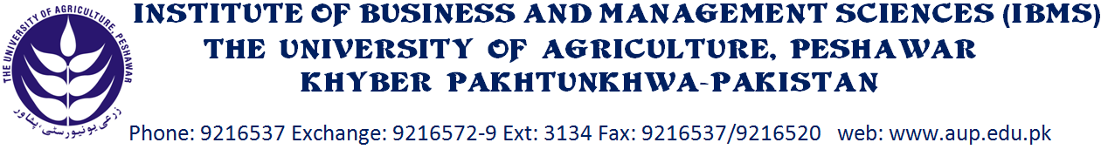
DEPARTMENT OF BUSINESS ADMINISTRATION
SCHEME OF STUDY FOR BBA (HONS)
BBA (HONS) 1st SEMESTER
Course code | SUBJECTS | Cr. Hrs
BBA-301 | Introduction to Business | 3
BBA-302 | Contemporary World | 3
BBA-303 | Arabic/Chinese etc I | 3
BBA-304 | Introduction to Computing | 3
BBA-305 | Islamic Studies | 3
BBA-306 | Freshman English 1 | 3
Total Credit Hours |  | 18

BBA (HONS) 2nd SEMESTER
Course code | SUBJECTS | Cr. Hrs
BBA-311 | Arabic/Chinese etc II | 3
BBA-312 | Microeconomics | 3
BBA-313 | Business Mathematics | 3
BBA-314 | Introduction to Management | 3
BBA-315 | Freshman English 1I | 3
BBA-316 | Pakistan Studies | 3
Total Credit Hours |  | 18

BBA (HONS) 3rd SEMESTER
Course code | SUBJECTS | Cr. Hrs
BBA-401 | Business Statistics | 3
BBA-402 | Macro Economics | 3
BBA-403 | Financial Accounting I | 3
BBA-404 | Introduction to HRM | 3
BBA-405 | Oral Communication | 3
BBA-406 | Human Psychology | 3
Total Credit Hours |  | 18

BBA (HONS) 4th SEMESTER
Course code | SUBJECTS | Cr. Hrs
BBA-411 | Financial Accounting II | 3
BBA-412 | Principles of Marketing | 3
BBA-413 | Pakistan Economics | 3
BBA-414 | Business Finance | 3
BBA-415 | Business Communication | 3
BBA-416 | Sociology | 3
Total Credit Hours |  | 18

BBA (HONS) 5th SEMESTER
Course code | SUBJECTS | Cr. Hrs
BBA-501 | Marketing Management | 3
BBA-502 | Logic | 3
BBA-503 | Business Law | 3
BBA-504 | Financial Management | 3
BBA-505 | Environmental Sciences | 3
BBA-506 | Specialization – I | 3
Total Credit Hours |  | 18
BBA (HONS) 6th SEMESTER
Course code | SUBJECTS | Cr. Hrs
BBA-511 | Consumer Behavior | 3
BBA-512 | Organizational Behavior | 3
BBA-513 | Business Ethics | 3
BBA-514 | Management Information System | 3
BBA-515 | Cost Accounting | 3
BBA-516 | Specialization – II | 3
Total Credit Hours |  | 18
BBA (HONS) 7th SEMESTER
Course code | SUBJECTS | Cr.Hrs
BBA-601 | Business Research & Report Writing | 3
BBA-602 | Operations Management | 3
BBA-603 | Entrepreneurship | 3
BBA-604 | Specialization – III | 3
Total Credit Hours |  | 12

BBA (HONS) 8th SEMESTER
Course code | SUBJECTS | Cr.Hrs
BBA-611 | Business Policy | 3
BBA-612 | International Business Mgt | 3
BBA-613 | Specialization – IV | 3
BBA-614 | Internship/Project Report | 6
Total Credit Hours |  | 15
Grand Total |  | 135
Finance Specialization
- Financial Reporting and Analysis
- Corporate Finance
- Financial Risk Mgt
- Investment Analysis And Portfolio Management
Marketing Specialization
- Sales & Selling
- Advertising & Promotional Strategies
- Online Marketing
- Supply Chain Management
HR/Management Specialization
- Strategic HRM
- Industrial Management & Labor Relations / Laws
- Recruitment & Selection
- Training and Organizational Development

